 | 
  ORBAN MICROWAVE PRODUCTS
  antenna application notes

Profile Distributors Press Contact us
 | 
  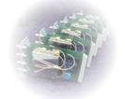
  The basics of patch antennas
  1. Introduction
  A microstrip or patch antenna is usually built on a piece of PC board. While the antenna can be a 3-D structure, wrapped around an object for example, the elements are usually flat. Hence their other name: planar antennas. Note that a planar antenna is not always a patch antenna.
  This article is an attempt to explain the basics of patch antennas. In addition to the single, linear polarized probe fed patch antennas, we will look at other types that have advantages over the latter. Before addressing the other types, we'll discuss general properties of this basic, probe fed, patch antenna.
  2. Properties of a basic microstrip patch
  The following drawing shows a patch antenna in its basic form: a flat plate over a ground plane. The center conductor of a coax serves as the feed probe to couple energy in and/or out of the patch.
  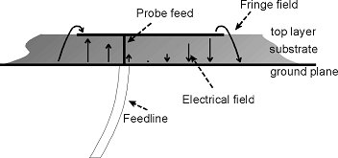
  The radiating element is a half wave resonating structure. An electric field exists between the patch and the ground plane. Near the edges, the field is not fully enclosed. This results in fringing fields, which in turn are the source of the radiation.
  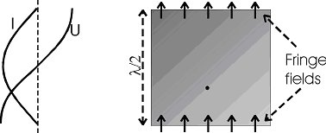
  The resonant length determines the resonant frequency and is about l/2.
  A better approximation is: L " 0.49 ld = 0.49
  · L = resonant length
  · ld = wavelength in microstrip
  · l0 = wavelength in free space
  · er = dielectric constant of the board
  Other parameters that will influence the resonant frequency:
  · Substrate thickness
  · Ground plane size
  · Metal (copper) thickness
  · Patch (impedance) width
  Looking at the current along the patch, we see it is maximum in the center and minimal near the top and bottom edges. The following picture shows the current distribution in an L-Band patch:
  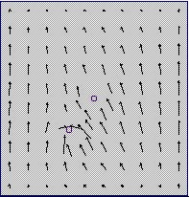
  From the magnitude of the current, we can conclude the impedance is minimum (zero W) in the middle of the patch and maximum (around 200 W) near the edges. In other words, somewhere along the vertical axis of the element, we can find a point where the impedance is 50 W. All that is left to be done is to solder a coax to the element.
  Assuming we can process a PC board with a reasonable accuracy, the production process is straightforward. The required accuracy is out of reach for Ham's, especially at the higher frequencies where one needs to be able to etch a board to within ± 0.05 mm or better. Up to say 1 GHz, the size of a single element is about 7 by 7 cm (assuming we use epoxy board with an er " 4) so the exact size is relatively non-critical. At 10 GHz and an element size of about 7 by 7 mm, life gets a lot more difficult.
  Another important parameter of any antenna is the bandwidth. The plot below shows the return loss for a WLAN patch antenna at 2.4 GHz. With a bandwidth of 2% we found the major disadvantage of basic patch antennas: they typically exhibit a bandwidth of less than 3%.
  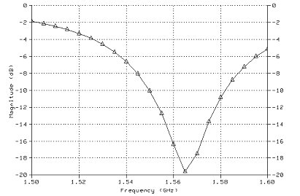
  There are techniques to increase the bandwidth of a basic patch.
  First, one can increase the thickness of the board. Though this works very well, a thicker board also increases the length of the feed probe and, as such, increases the inductance of that feed probe. This effectively again reduces the bandwidth from a certain thickness onwards.
  Another way to get more bandwidth is to increase the width of the antenna: a larger structure yields a smaller Q, giving us some bandwidth increase. The practical bandwidth limit with this structure is around 5%.
  In recent years, a lot of work has been done to increase the bandwidth of these antennas and we'll discuss the subject in more detail below.
  The last property of interest is the gain.
  The radiating element is mounted over a ground plane. Assuming a perfect front to back ratio, that is a 3 dB gain increase. The radiating sides of the patch can be seen as two dipoles: since there are two of them, that is another 3 dB. Furthermore, an increase in thickness will also increase the gain. The maximum practical thickness will get another 2 to 3 dB of extra gain.
  Adding these, we have a total of 8 to 9 dB. Do note this is not possible with a basic patch. Other techniques to further increase the gain exist but these fall beyond the scope of this article.
  3. Other feed types
  The probe feed discussed above is perfectly suited for a lot of applications. A GPS antenna is a good example.
  
  Another way to connect to the patch is a microstrip line a the edge of the element:
  
  With this type of feed, we obviously need to transform the impedance to a useful value. However, the transformer itself tends to radiate and influence the radiation pattern of the antenna. The advantage of this structure is that, for example, amplifiers can be placed near the elements. Also, elements can be connected in parallel in the same plane to form an array.
  A nice solution is a combination of the two foregoing solutions:
  
  We keep the microstrip feed but create an inset to find the 50 W point. The compromise here is that the gaps will influence the radiation pattern of the element. The advantage on the other hand is that we can now connect a 50 W gain block straight to the element.
  4. Bandwidth and even more feed types
  The bandwidth of our single planar element is a couple % at best. The total bandwidth of a patch, however, is a combination of at least two bandwidths:
  · Radiation bandwidth
  · Feed system bandwidth
  The radiation bandwidth of just the element can be up to 50%. The feed system can be as narrow as 0.1%. Obviously, we need to work on the feed to increase the bandwidth.
  An often used topology is a so-called aperture coupled patch: a slot is cut in the ground plane under the radiating element and the slot is then excited with a microstrip line over the slot on the opposite side of the ground plane.
  The following drawings show this:
  
  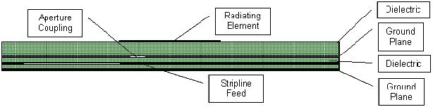
  This feed will effectively increase the bandwidth of the antenna. The following plot shows the return loss of an aperture coupled patch for WLAN at 2.4 GHz:
  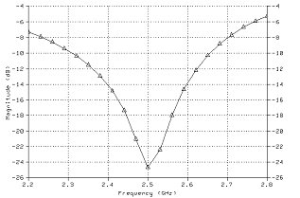
  Bandwidths of 10% can be readily achieved but, clearly, this structure becomes very complicated to design.
  5. Circular polarization
  The basic element discussed above gives us linear polarization. The L-Band patch mentioned yields vertical polarization as shown. When we flip the antenna 90°, the current flows in the horizontal plane, and we get horizontal polarization.
  To get circular polarization, we need to do three things:
  · Split the signal in two equal parts
  · Feed one signal to a horizontal radiator and the other to a vertical radiator
  · Change the phase of one of the signals by 90°
  Splitting the signal in half can be done with a Wilkinson or similar splitter. If we build a patch with two feed points, we have created a vertical and a horizontal radiator. By creating the 90° delay in one of the signal lines and connecting each signal to one feeding pin of the patch, we built a circularly polarized antenna.
  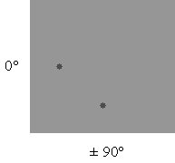
  Though this works well, the splitter and delay line take up valuable board space and they also tend to radiate and degrade radiation pattern.
  Another approach is to see the patch as a parallel RLC resonant circuit. This means we can see a phase shift that changes versus frequencies shown in the following plot:
  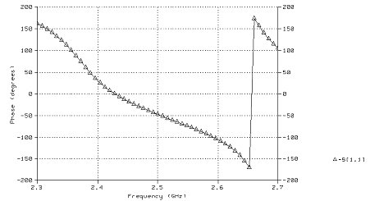
  This is interesting: the phase change is sufficient over a narrow bandwidth to create the required 90° shift and still yield 'two' useful antennas. What we have to do is to build a patch with two resonant frequencies and use the antenna right in between the two resonances. A number of ways exist to implement this, but cutting two corners off the element, the so-called corners truncated patch, is a technique widely used in GPS antennas.
  The following drawing shows this type of antenna:
  
  6. Conclusions
  The basic patch is easy to build but has a number of clear disadvantages; the limited bandwidth being the number one problem. Increasing the bandwidth is a practical way to make a design resistant against tolerances. The problem there is that the extremely complex design challenges cannot be solved with low cost tools.
  - BACK | TOP -
RF and microwave design Antenna design Profile Distributors Press Contact us

