The Third Element- Report

Organising institution: Croatian Radiotelevision, The Third Element – TV show

Date: 17th October 2018

Description.

The Third Element is a television show that deals with various topics from all areas of science. It consists of a thematic interview in a studio with two leaders and two guests and a number of attachments recorded in scientific laboratories. The goal of the Third element is to introduce viewers with the latest achievements of modern science and the almost amazing technologies that have been created by their application, but also to talk about many controversial issues and present different views. In the episode Accelerators, among other, CA16101 MULTIFORESEE was presented.
Show is in Croatian and can be see on YouTube https://www.youtube.com/watch?v=BrdiWWxm0kA&fbclid=IwAR23lt5fqXyVJJVdCptNrlql6pFwolSznwj2e0rK5-k30YggwYgrs888pmg

Photos.
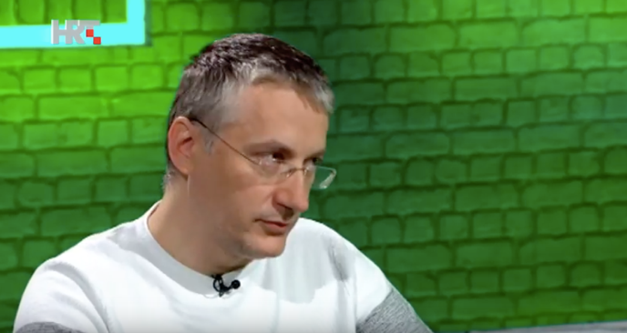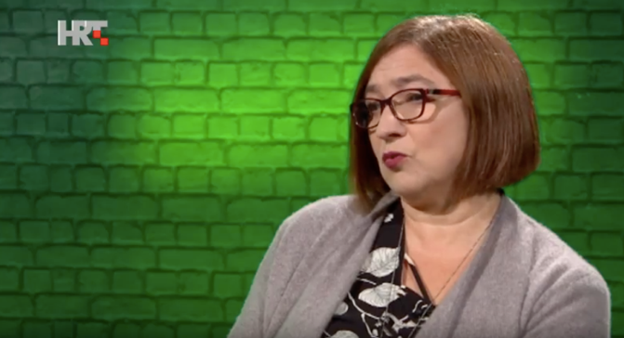

Report prepared by: Iva Bogdanović Radović

