Summer School of Science- Report

Organising institution: Society for Out-of-Frame Education, Požega, Croatia

Venue: Gymnasium Požega

Date: August 8th - 18th, 2018

Description.

Summer School of Science is international summer workshop for high school students which offeres a diverse range of research projects and lectures in the fields of science and technology. During the school students get chance to work in small groups on a real scientific projects guided by a mentor. This is accompanied by evening lectures from eminent scientisit from all over the world. On 10th August Iva Bogdanović Radović gave an invited lecture: “A view in the exciting world of molecules – from art to forensics”.

Photos.
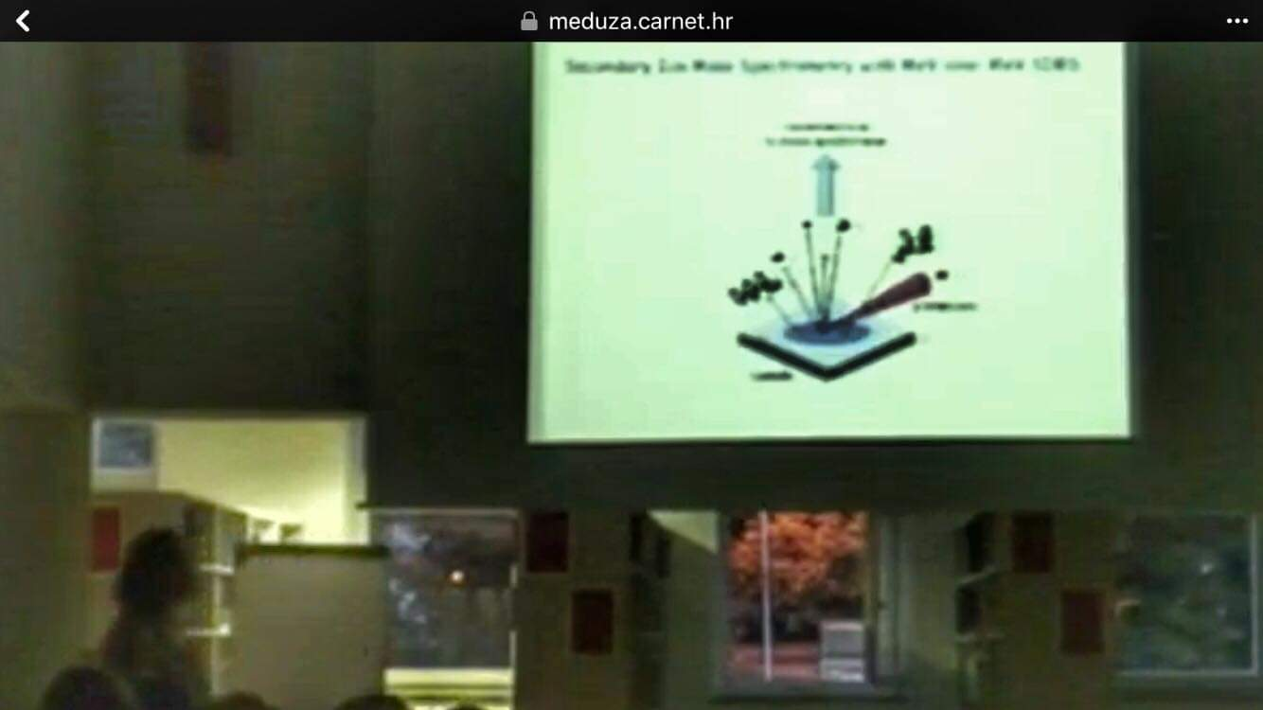

Report prepared by: Iva Bogdanović Radović

